USER GUIDE  
PETBot Company

1. **Overview**- This website contains Home, Product chart, Contact Us, Register, Login, Site map, Category (Food and beverage, Pharmaceutical, Healthcare, Industry, Honey), Quick Order, Our catalogue, Feedback, Our Gallery.  
   - Before you begin, please make sure that you have a working internet connection and please login an email account in Mail APP before to use send Feedback email.  
   - Click on Home.html locate inside the folder Source Code file to get start
2. Instruction

This section contains some instruction on how to navigate the website:  
1. Company name- Company name lives on the top center of the page. This is PETBot Company.  
2. Navigation bar- Navigation bar contain information about all the main pages of the website, locate below the company name, right column and left column.  
- To go to a particular page, click on the page name in the navigation bar:  
- To go to home page, please click on HOME

- To go to Product chart, please click on PRODUCT  
- To go to Contact us page, please click on CONTACT US

- To go to Register page, please click on REGISTER

- To go to login page, please click on LOGIN

- To go to Site Map, please click on SITE MAP

- To go to Order, please click on Quick Order (right column)

- To go to see our Catalogue, please click on Our Catalogue (right column)

- To go to send feedback, please click on Feedback (right column)

- To go to see our gallery, please click on Gallery (right column)  
- To go to Food bottle or Food jars, please hover on Food and Beverage, there will be a drop-down options for you to choose Food bottle or Food jars. (left column)

- To go to Pharmaceutical, please click on Pharmaceutical (left column)

- To go to Healthcare bottle or Healthcare jars, please hover on Healthcare, there will be a drop-down options for you to choose Healthcare bottle or Healthcare jars. (left column)

- To go to Industry, please click on Industry (left column)

- To go to Honey, please click on Honey (left column)  
III. Information about the Web pagesThis section contains information about each page in the website

1. **Homepage:**

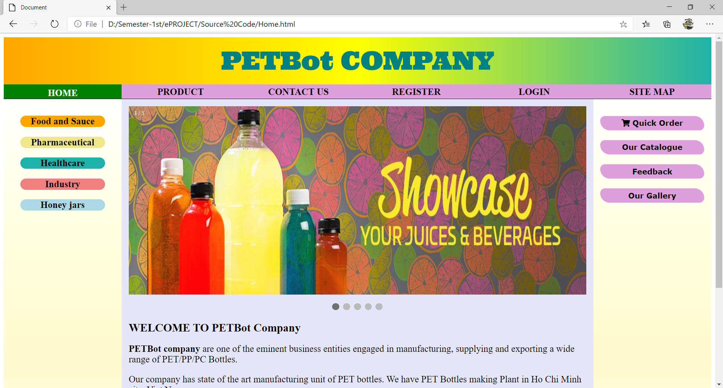

**Description** : Home page: Company introduction and carousel.

**From** : Home navigation bar

**To** : Product, Contact Us, Register, Login, Site Map, Category, Our Gallery, Our Catalogue, Quick Order, Feedback.

1. **Product:**

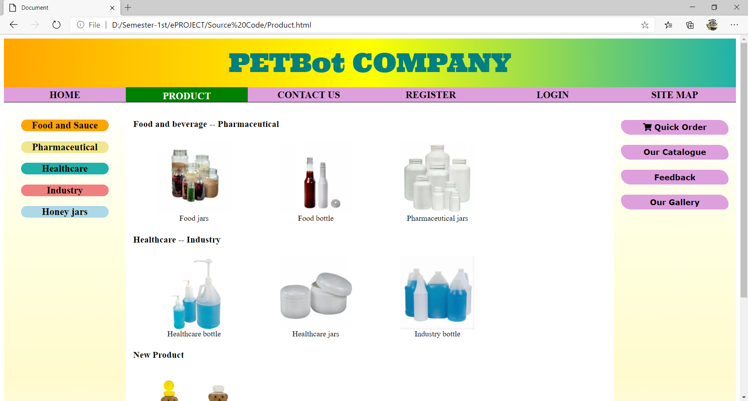

**Description** : Product: You can see product chart and go to the wanted product page by click the picture of this product.

**From** : Home / Our Product navigation bar

**To** : Home, Contact Us, Register, Login, Site Map, Category, Our Gallery, Our Catalogue, Quick Order, Feedback.

1. **SITE MAP:**

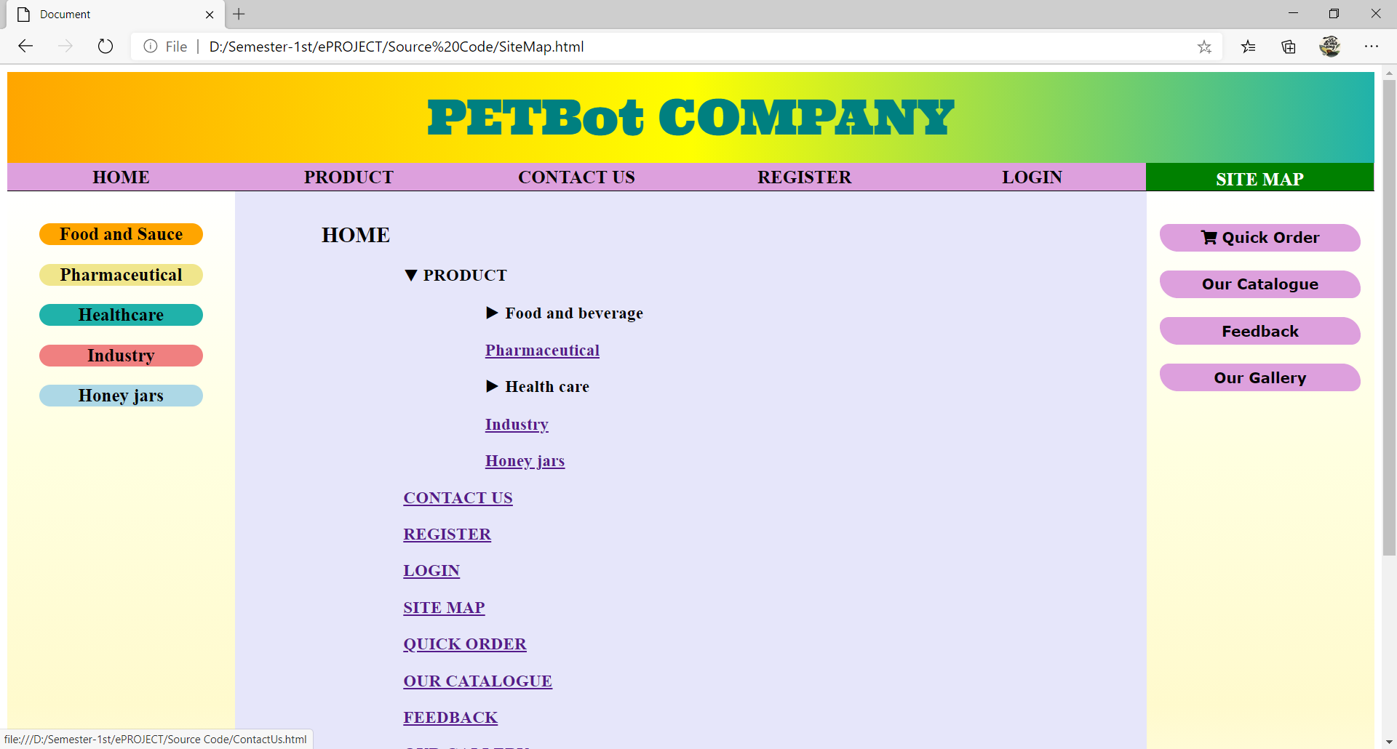

**Description** : Site Map: you can see site map and go directly the wanted page by click the name page in the site map

**From** : Home / Site Map navigation bar

**To** : Home, Contact Us, Register, Login, Product, Category, Our Gallery, Our Catalogue, Quick Order, Feedback.

1. **Gallery:**

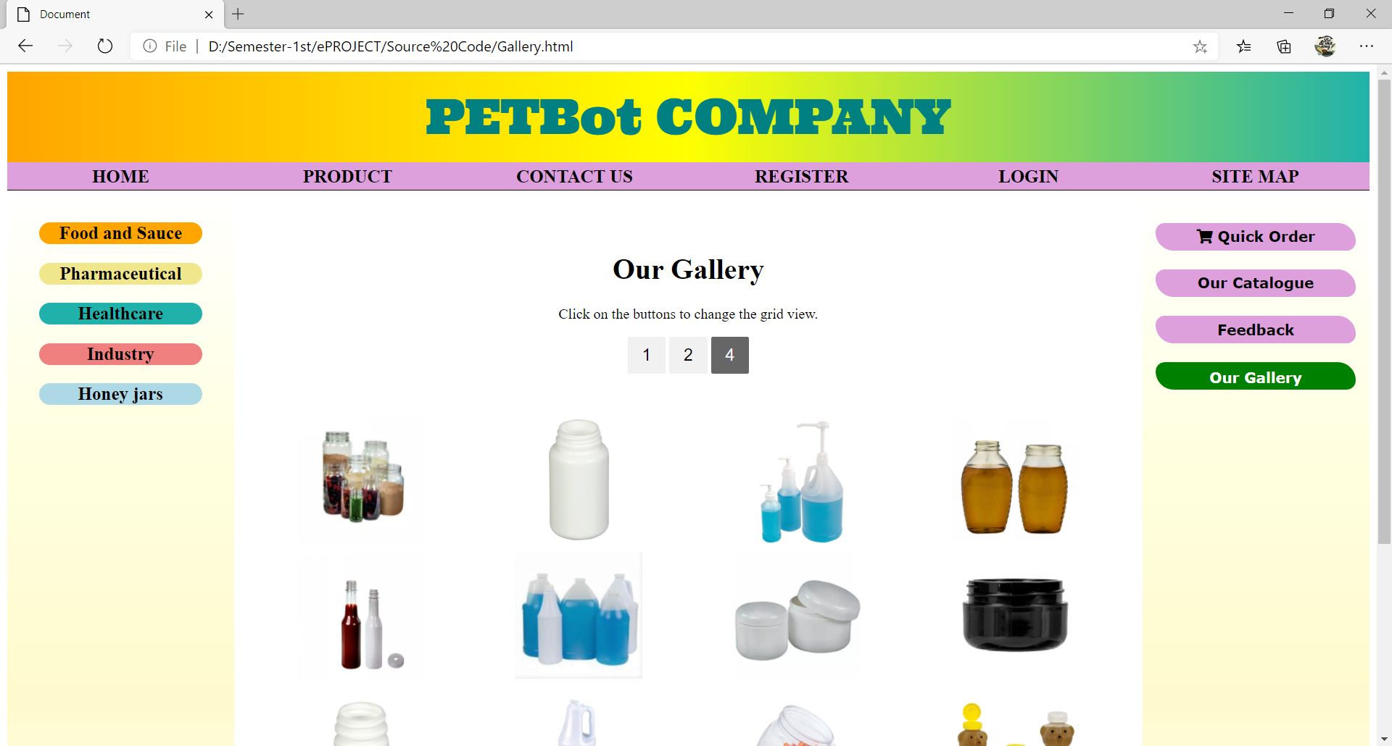

**Description** : Gallery: hover product picture, you can see the tittle of category of product that can help you find product easily by category.

**From** : Home / Gallery navigation bar

**To** : Home, Contact Us, Register, Login, Our Product, Category, Site Map, Our Catalogue, Quick Order, Feedback.

1. **CATEGORY:**

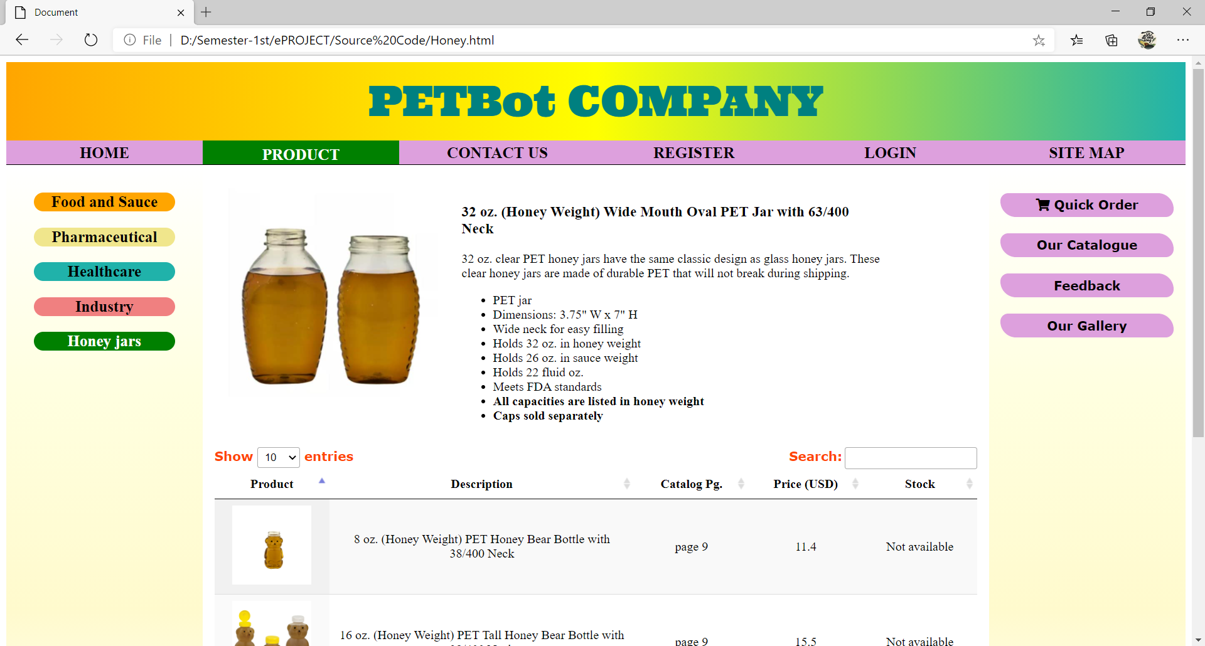

**Description** : Category left column: Pharmaceutical/Food bottle/Food jars/Industry/Healthcare bottle/Healthcare jars/Industry/Honey jars

**From** : Home / Product navigation bar / Category (…)

**To** : Home, Contact Us, Register, Login, Site Map, Category, Our Gallery, Our Catalogue, Quick Order, Feedback.

1. **FEEDBACK**

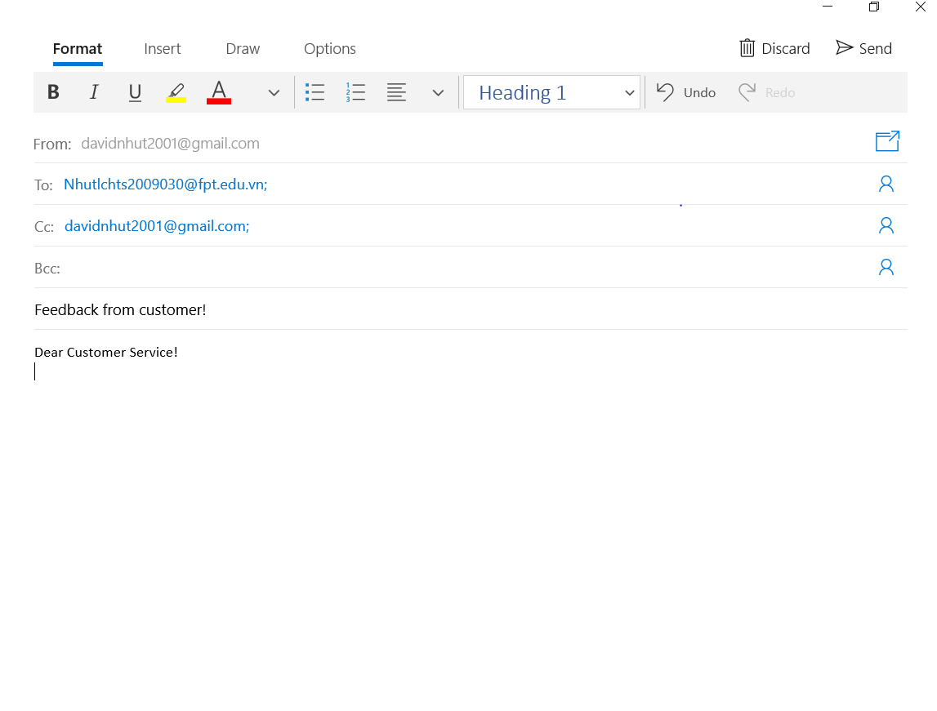

**Description** : Feedback button: when our customer click on Feedback button (right column), mail app email with subtitle, email and cc email that we already set up. The customer should login an email account in Mail App before.

**From** : Home / Feedback navigation bar (right column)

1. **CONTACT US**

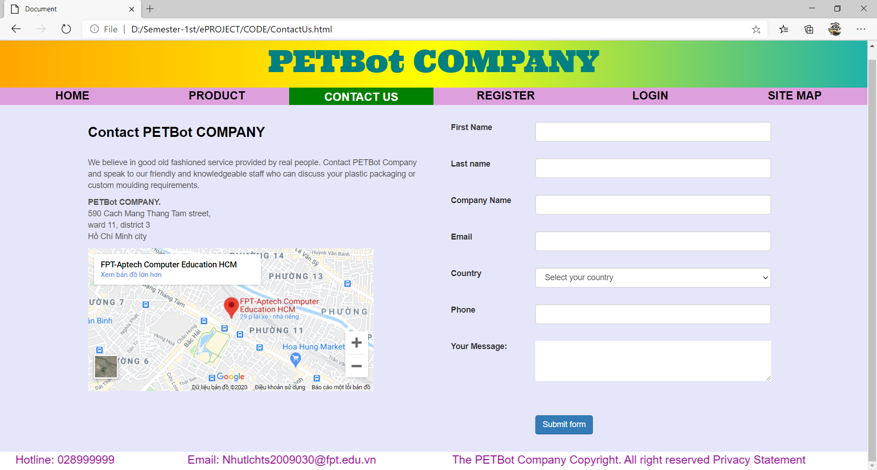

**Description** : Contact Us: Contact form and Geolocation. You should enter you information (such as first name, last name, email, country, phone and your message)

**From** : Home / Contact Us navigation bar

**To** : Home, Product, Register, Login, Site Map

1. **REGISTER**

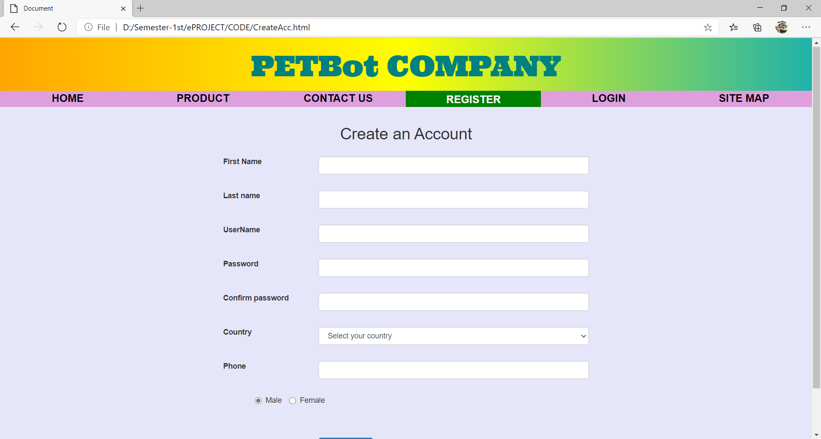

**Description** : Register : Register form to create new account

**From** : Home / Register navigation bar

**To** : Home, Product, Contact Us, Login, Register, Site Map,

1. **LOGIN:**

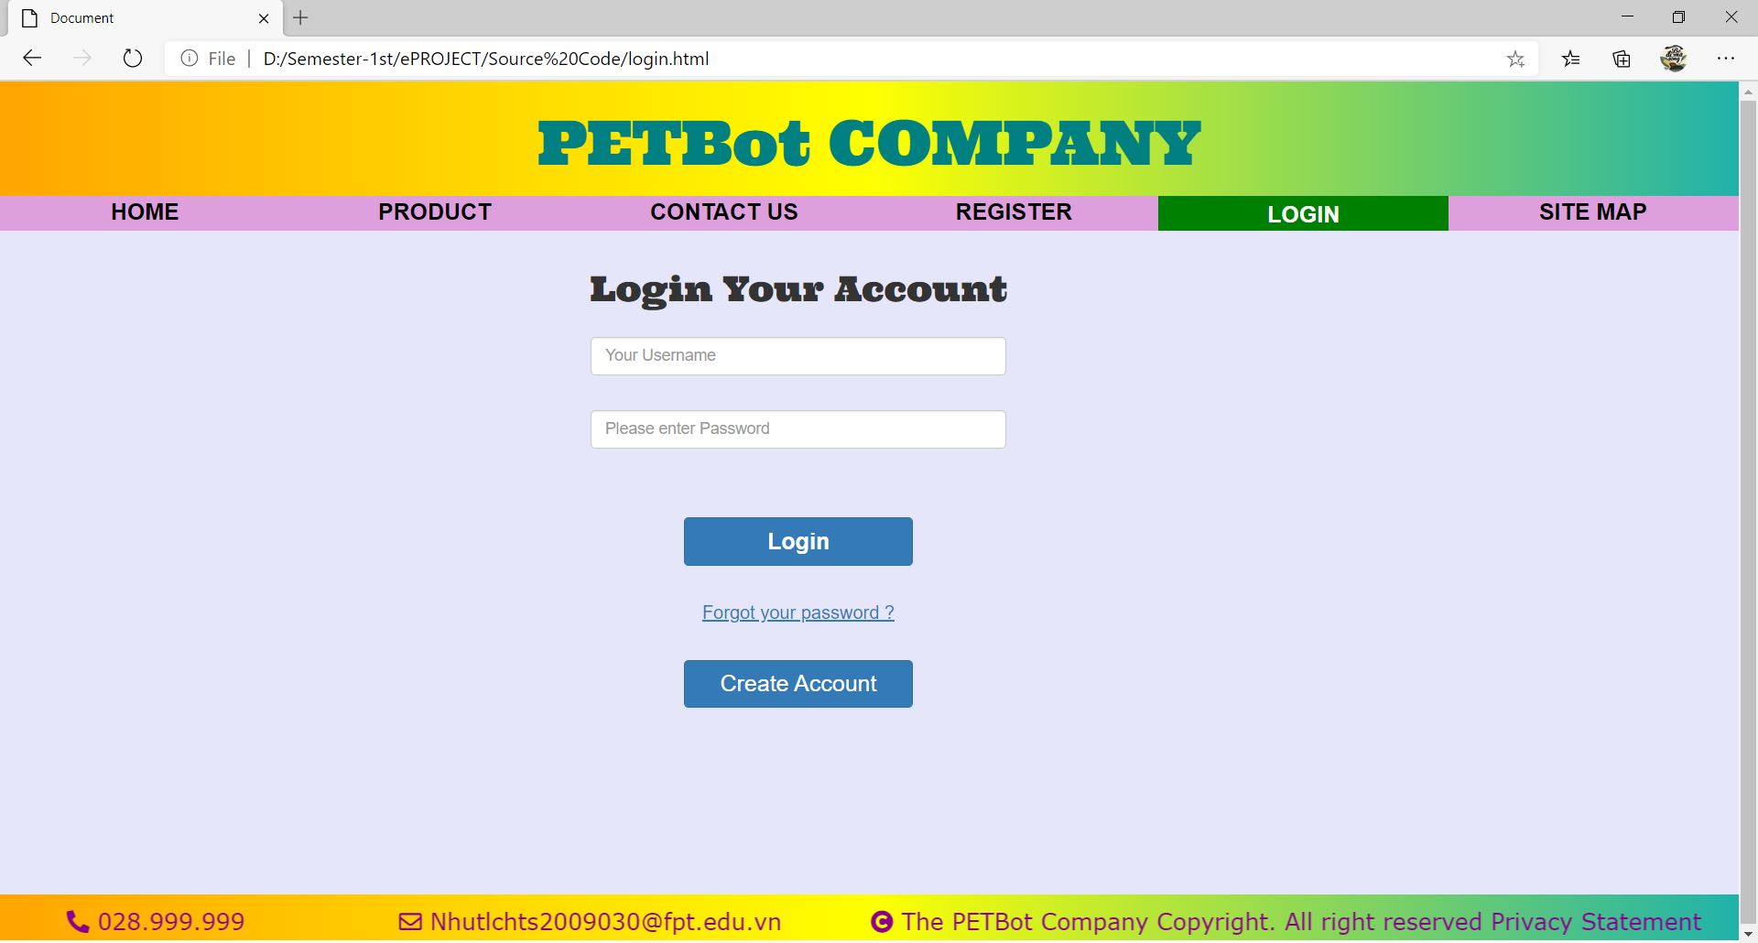

**Description** : Login : Login your account form

**From** : Home / Login navigation bar

**To** : Home, Our Product, Contact Us, Login, Register, Site Map,

1. **Quick Order:**

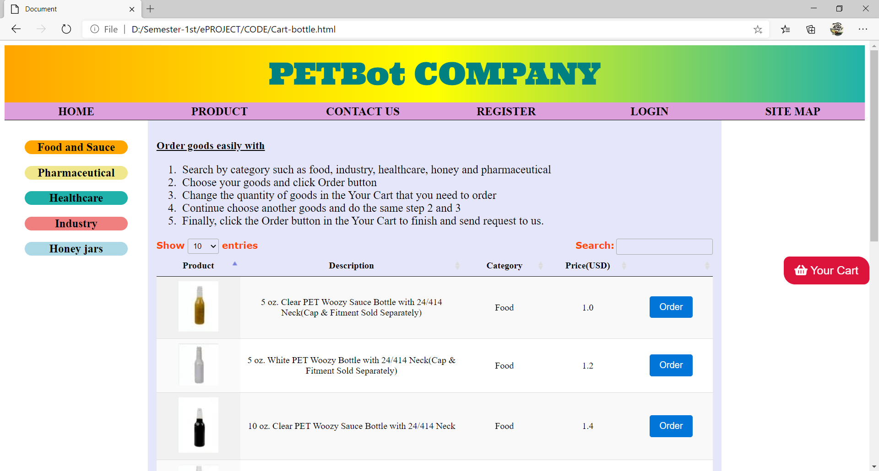

**Description** : Quick Order : Cart and list of all product with description, category, price and order button

**From** : Home / Quick Order navigation bar

**To** : Home, Our Product, Contact Us, Login, Register, Site Map, Category,

1. **Our Catalogue:**

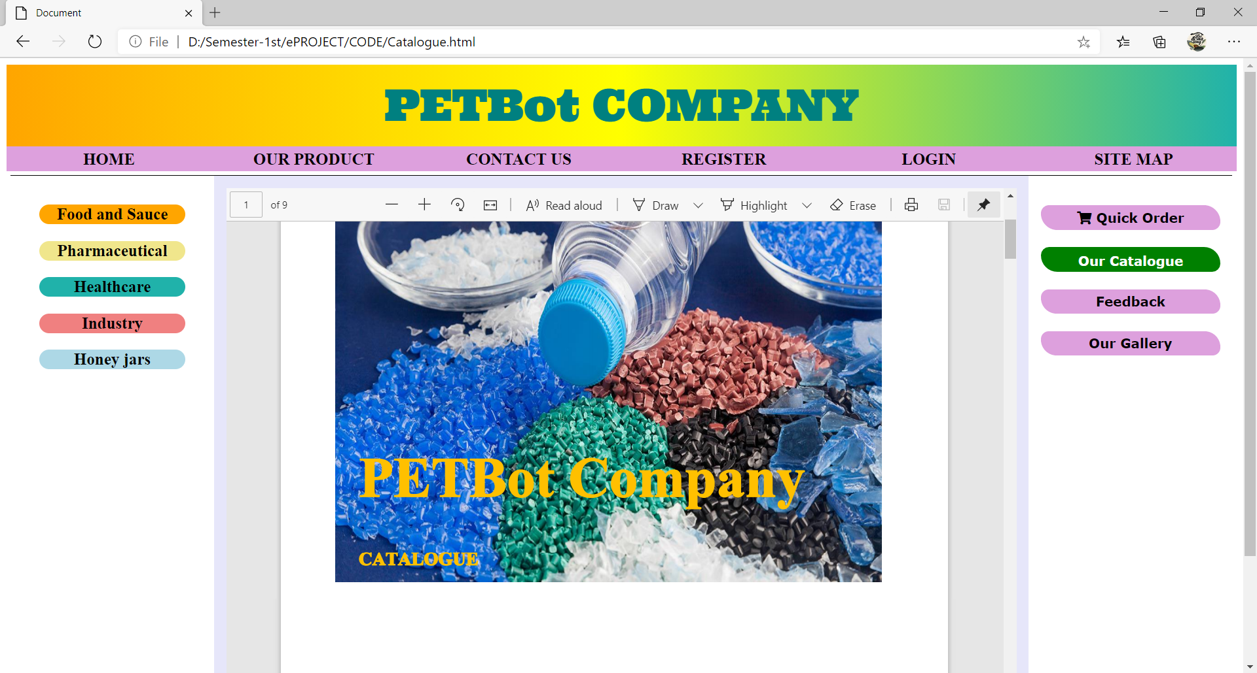

**Description** : Our Catalogue : Catalogue.pdf

**From** : Home / Our catalogue navigation bar

**To** : Home, Our Product, Contact Us, Login, Register, Site Map, Category,

Quick Order, Feedback, Our Gallery.